Labwork 1: Install MySQL and Employees Database

Student Information
- Name: Phan Huyền Diệu
- Student ID: 2640068
- Date: 03/11/2026

Objective
The objective of this lab is to:
- Install MySQL Server and MySQL Workbench.
- Clone the Employees sample database from GitHub.
- Import the Employees database into MySQL.
- Verify that the database has been installed correctly.

Step 1: Install MySQL
I downloaded and installed:
- MySQL Server 2022
- MySQL 8.4
- MySQL Workbench
- After installation, I set up the MySQL service and MySQL 8.4.

Step 2: Clone the Employees Database
I right clicked the folder I want the file to be installed and choose Open Git Bash here and executed:
git clone https://github.com/datacharmer/test_db
Result:
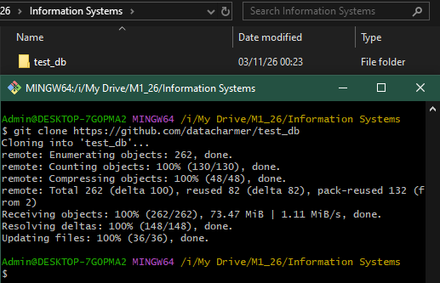
This created the folder:
test_db

Step 3: Create the Employees Database
I opened Command Prompt and run:
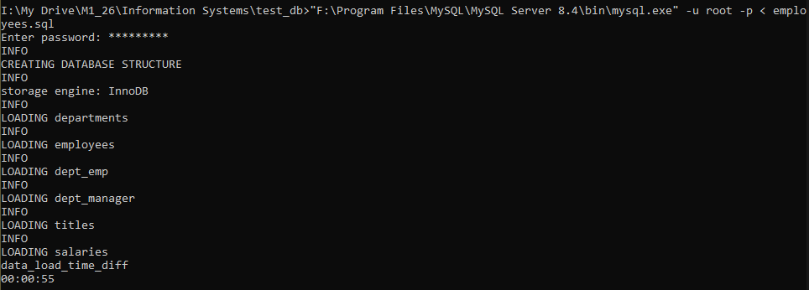
I waited until the script finishes creating tables and loading data.

Step 4: Verify the Database
I opened MySQL Workbench
Entered the MySQL root password.
Database show in SCHEMAS
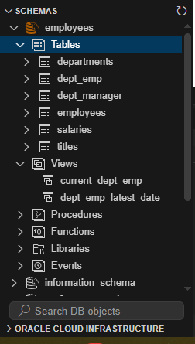

Show available databases:
SHOW DATABASES;
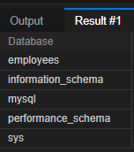

Select the employees database:
USE employees;

Show tables:
SHOW TABLES;
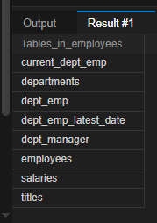

Count employee records:
SELECT COUNT(*) FROM employees;
300024

Run a sample query:
SELECT * FROM employees LIMIT 5;
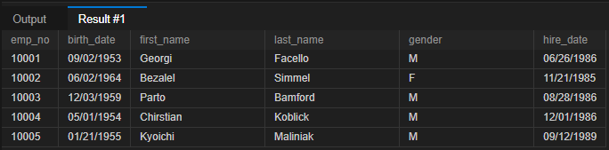

Conclusion
The MySQL Server and MySQL Workbench were successfully installed. The Employees sample database was cloned from GitHub and imported into MySQL. Verification queries confirmed that the database and its tables were created correctly and contain the expected data.

Commands Used
git clone https://github.com/datacharmer/test_db
cd "I:\My Drive\M1_26\Information Systems\test_db"
dir
"F:\Program Files\MySQL\MySQL Server 8.4\bin\mysql.exe" -u root -p < employees.sql
SHOW DATABASES;
USE employees;
SHOW TABLES;
SELECT COUNT(*) FROM employees;
SELECT * FROM employees LIMIT 5;

